**GetIN mobile app extends service to ‘hard-to-reach’ young pregnant women**

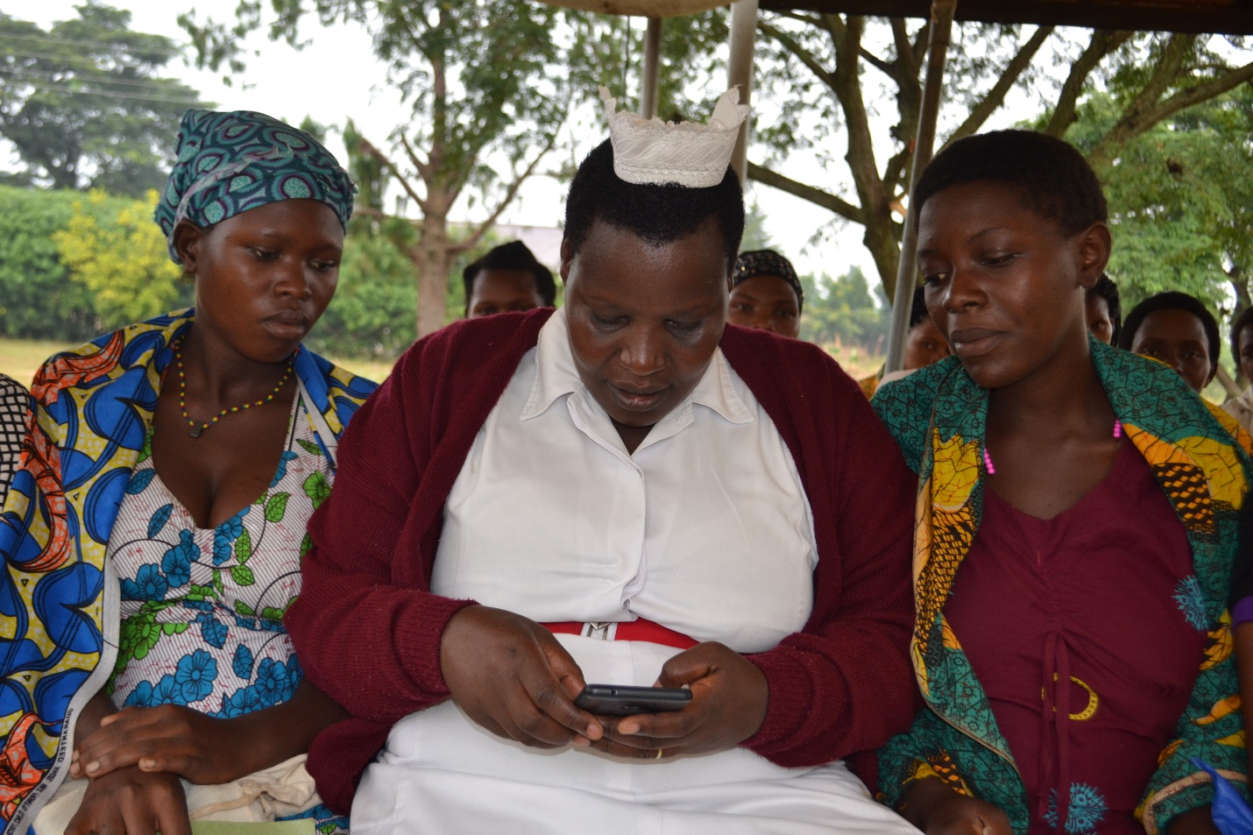

**(Please add caption)**

After a successful pilot and launch in Kanungu district (Date), GetIN mobile has extended the use of its mobile application to the neighboring Bundibugyo district of South Western Uganda. GetIN is an online platform for health care providers to strengthen the linkage and integration between health care providers and young pregnant women to acccess timely and quality maternal health care.

Supported by UNFPA and developed and implemented by young people, GetIN mobile application is part of UNFPA’s 15 years of continuous efforts to improve youth-friendly and maternal health service delivery in the district.

The mobile application enables health care providers to reach out to the “hard-to-reach” young pregnant women, map their physical location, and send key maternal health messages up until the three-month post pregnancy period, thereby improving their knowledge on how to ensure safe motherhood and post-partum family planning.

GetIN also collects accurate information of the young pregnant women (below 25 years old) and reports the data to a central dashboard, which is monitored by District Health Officer and District Bio-statistician. The dashboard provides information of the work done by the health care providers and creates an opportunity for the district health team to respond to any noted challenges in real time.

According to the area specific profile for the National Population Census 2014 of Bundibugyo District, 58 percent of the district population is below 24 years, with teenage pregnancy rate as high at 25 percent, equaling the national average.

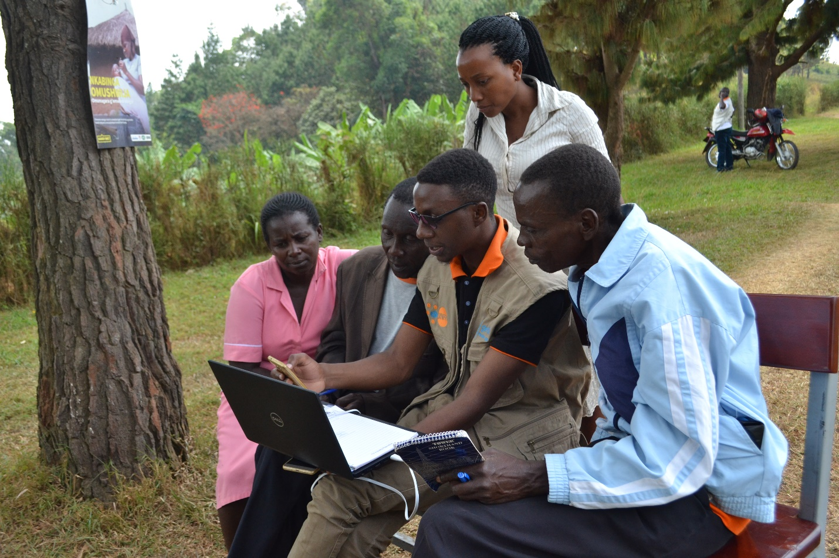

(Please add caption)

In his remarks at the launch, the District Health Officer Dr. Christopher Kiyita, appreciated how technology today can be used to enhance access to health services in the hard- to- reach hilly district with lack of infrastructure and bears transport challenges: “Here, it is hard for our young mothers to access health facilities due to geographical distance and stigmatization of pregnant girls in our communities. So it is important to follow them up and encourage them to seek for services at the health facility,” he added.

GetIN will be rollout in 17 health facilities, where 53 volunteers; (34 Village Health Team members and 17 midwives) will be trained and equipped a smartphone for mapping and following up young pregnant mothers especially teenage girls (to do what?). UNFPA will also provide the district with two computers for use to monitor progress on a regular basis.

UNFPA believes that through innovative solutions, Uganda will register great improvements in sexual and reproductive health indicators for women and girls.

**Story by Cedric Muhebwa**